**Name: …………………………………………………………Class: ………….….Adm.No. ……………**

**232/2 Candidate’s Signature: …………………...**

**PHYSICS**

**Paper 2**

**OCTOBER 8TH**

**Time: 2 hours**

**TRIALS E X A M I N A T I O N**

**Kenya Certificate of Secondary Education**

**Instructions to Candidates**

* *Write your name, admission number, class and signature in the spaces provided at the top of the page. This paper consists of two sections;* ***A*** *and* ***B.***
* *Answer* ***ALL*** *the questions in the spaces provided.*
* *Mathematical tables and electronic calculator may be used.*
* *This paper consists of 11 printed pages.*
* *Candidates should answer the questions in English*
* *You may use the following constants where necessary:-*

**FOR EXAMINER’S USE ONLY**

|  |  |  |  |
| --- | --- | --- | --- |
| **SECTION** | **QUESTIONS** | **MAXIMUM SCORE** | **CANDIDATE’S SCORE** |
| **A** | 1 – 11 | 25 |  |
| **B** | 12 | 09 |  |
|  | 13 | 08 |  |
|  | 14 | 10 |  |
|  | 15 | 09 |  |
|  | 16 | 10 |  |
|  | 17 | 09 |  |
| **TOTAL SCORE** | | **80** |  |

**SECTION A: (25 MARKS)** (Answer all)

1.Sophi cleaned a zinc plate and fixed it on the cap of a charged gold leaf electroscope.When she shone ultraviolet light on the zinc plate she noticed that the leaf divergence slowly decreased.

i)What is the initial charge on the electroscope. (1mark)

……………………………………………………………………………………………………..

ii)Explain why the leaf divergence decreased. (2marks)

………………………………………………………………………………………………………………………………………………………………………………………………………………

………………………………………………………………………………………………………………………………………………………………………………………………………………

2.A step-up transformer is designed to operate from a 20V supply and deliver electrical energy at 240V.If the transformer is 90% efficient, Determine the current in the primary coil when the output terminals are connected to a 240V 100W light bulb. (3marks)

………………………………………………………………………………………………………………………………………………………………………………………………………………

………………………………………………………………………………………………………………………………………………………………………………………………………………

………………………………………………………………………………………………………………………………………………………………………………………………………………

3.State two conditions necessary for total internal reflection to occur . (2marks)

………………………………………………………………………………………………………………………………………………………………………………………………………………

………………………………………………………………………………………………………………………………………………………………………………………………………………

4.Explain why an α-particle produce a straight- line track in a cloud chamber whereas a β- particle produces a straggly (irregular) track. (1mark)

………………………………………………………………………………………………………………………………………………………………………………………………………………

5 Figure below shows a faulty domestic wiring system . Identify the fault hence sketch the correct set-up beside it . (2marks)

**Appliance**

**L**

**N**

………………………………………………………………………………………………………………………………………………………………………………………………………………

………………………………………………………………………………………………………………………………………………………………………………………………………………

6.i)Arrange the following in order of increasing energy. Visible light, infrared radiation, x-rays, U.V.radiation, radio waves. (1mark)

………………………………………………………………………………………………………………………………………………………………………………………………………………

ii)State one detector of infrared radiation. (1mark)

………………………………………………………………………………………………………

7 The figure below represents and object O placed 10cm in front of a diverging lens. F is the focal point of the lens.

**F**

**O**

Draw rays to locate the position of the image. (3marks)

8.Study the circuit diagram below and answer the question that follow.

**8 Ω**

**12Ω**

If the power in the 12Ω resistor is 6W, determine;

1. the current in the 8Ω resistor. (3marks)

………………………………………………………………………………………………………………………………………………………………………………………………………………

………………………………………………………………………………………………………………………………………………………………………………………………………………

1. Total voltage supplied by the battery. (1mark)

………………………………………………………………………………………………………………………………………………………………………………………………………………

9.Explain how lighting a match box near the cap of a charged electroscope would cause the electroscope to discharge (2marks)

………………………………………………………………………………………………………………………………………………………………………………………………………………

………………………………………………………………………………………………………………………………………………………………………………………………………………

10.Sketch the electric field pattern for a negative point charge placed near a positively charged plate. (2marks)

11.Define work function of a metal. (1mark)

………………………………………………………………………………………………………………………………………………………………………………………………………………

**SECTION B: (55MARKS)**

12a)A magnetic compass needle is placed below a current carrying conductor as shown below.

**N**

**Conductor**

Indicate on the diagram the direction of the current. (1mark)

b) State Fleming,s left-hand rule(motor rule) . (1mark)

………………………………………………………………………………………………………………………………………………………………………………………………………………

………………………………………………………………………………………………………………………………………………………………………………………………………………

c) State two physical modifications that can be made on the **coil** of an electromagnet to increase its magnetic strength. (2marks)

………………………………………………………………………………………………………………………………………………………………………………………………………………

d) Give two applications of electromagnets. (2marks)

………………………………………………………………………………………………………………………………………………………………………………………………………………

e) Explain the working of the telephone receiver shown below. (3marks)

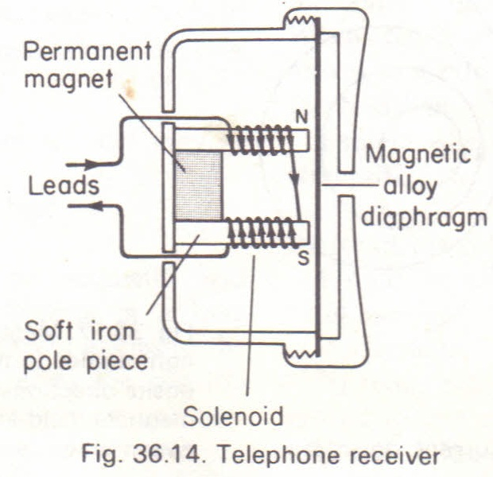

………………………………………………………………………………………………………………………………………………………………………………………………………………

………………………………………………………………………………………………………………………………………………………………………………………………………………

………………………………………………………………………………………………………………………………………………………………………………………………………………

13a) State the functions of the following parts of a C.R.O.

i) Grid. (1mark)

………………………………………………………………………………………………………………………………………………………………………………………………………………

ii) X – plates. (1mark)

………………………………………………………………………………………………………………………………………………………………………………………………………………

b) An X-raytube is operated at an accelerating potential of 100kV and only 0.05% of the energy of the electrons is converted to X-rays, calculate the wave length of the generated X-rays. (Take electric charge e = 1.6 x10-19 C, planks constant )

h = 6.63 x 10-34 Js, and speed of light c = 3.0 x 108m/s ). (3marks)

………………………………………………………………………………………………………………………………………………………………………………………………………………

………………………………………………………………………………………………………………………………………………………………………………………………………………

………………………………………………………………………………………………………………………………………………………………………………………………………………

c ) State **one** industrial application of X-rays . (1mark)

………………………………………………………………………………………………………………………………………………………………………………………………………………

d) State how the following can be controlled in an X-ray tube

(i) Intensity . (1mark)

………………………………………………………………………………………………………………………………………………………………………………………………………………

(ii) The exposure to stray X-rays. (1mark)

………………………………………………………………………………………………………………………………………………………………………………………………………………

14.a) In an attempt to establish the relationship between current through a junction- diode and the p.d across it, a student connected a diode to a d.c source as shownbelow:-

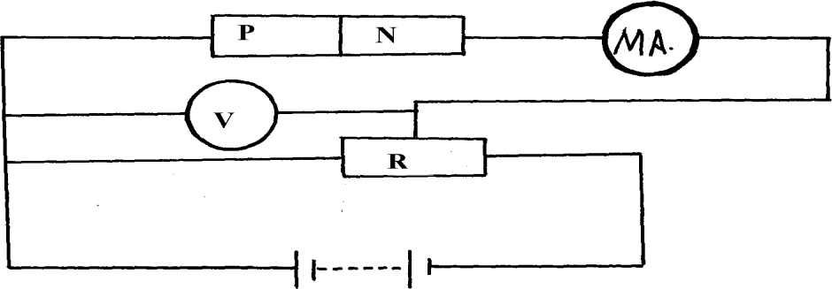

i)State whether the diode is forward biased or reverse biased. (1mark)

……………………………………………………………………………………………………..

ii)Briefly describe how she obtained her readings. (2marks)

………………………………………………………………………………………………………………………………………………………………………………………………………………………………………………………………………………………………………………………………………………………………………………………………………………………………

iii)Sketch a graph to represent the relationship between current (y-axis) and the

p.d across the diode. (1mark)

b) The diagram below shows a rectifier circuit for an alternating current (a.c) input.  
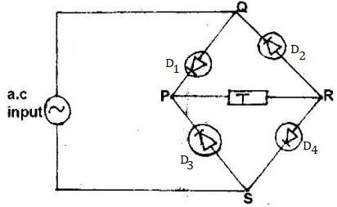

i)Describe the rectification process. (2marks)

………………………………………………………………………………………………………………………………………………………………………………………………………………………………………………………………………………………………………………………………………………………………………………………………………………………………

ii) Insert a capacitor in circuit (b) above and state its function. (2marks)

………………………………………………………………………………………………………………………………………………………………………………………………………………………………………………………………………………………………………………………

c)State two ways in which electrical conductivity of a semiconductor can be enhanced.

(2marks)

………………………………………………………………………………………………………………………………………………………………………………………………………………

15. a) (i) During an experiment to determine the speed of sound in air, Ramona discovered that on a cold day the speed of sound in air is 300 m/s. State and explain what she would observe if she did the experiment on a hot day. (1 mark)

………………………………………………………………………………………………………………………………………………………………………………………………………………………………………………………………………………………………………………………

(ii) A pulse of sound is sent from sea surface to the seabed and its echo received after 0.6 seconds. Determine the depth of sea given that velocity of sound in sea water is 1500 m/s.

(2 marks)

………………………………………………………………………………………………………………………………………………………………………………………………………………………………………………………………………………………………………………………………………………………………………………………………………………………………

b) The figure below shows a displacement-time graph of a water wave traveling at 320ms-1. The wave takes 1.2 seconds to move from point A to B. 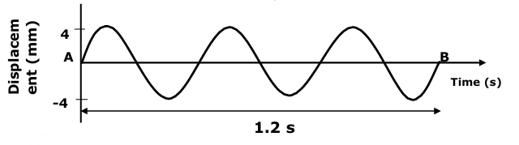

determine the wavelength of the wave. (3marks)

………………………………………………………………………………………………………………………………………………………………………………………………………………………………………………………………………………………………………………………………………………………………………………………………………………………………

c. (i) The figure below shows wave front approaching a concave surface.

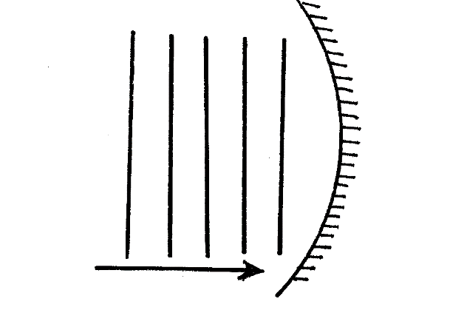

Complete the diagram to show wave fronts formed after striking the surface. (2marks) (ii) State one differences between progressive wave and a stationary waves. (1mark)

………………………………………………………………………………………………………………………………………………………………………………………………………………

16a)Define the term electromotive force as used in current electricity. (1mark)

……………………………………………………………………………………………………………………………………………………………………………………………………………………………………………………………………………………………………………………..

b)The figure below shows a simple cell

**Bulb**

Solution A

**Zinc plate**

**Copper plate**

i)Identify the function of solution A. (1mark)

………………………………………………………………………………………………………………………………………………………………………………………………………………

ii)Explain why the bulb goes off after only a short time. (1mark)

………………………………………………………………………………………………………………………………………………………………………………………………………………

c)The figure below is a filament bulb that uses 240V mains supply connected to only two wires



(i) Which wire, earth, live or neutral, is **not** needed in the cable for the lamp? (1mark)

…………………………………………………………………………………………..

**(ii)** Give one advantage of fluorescent lamp over filament lamp. (1mark)

………………………………………………………………………………………………………………………………………………………………………………………………………………

iii)Why do the tungsten filament wire have a very small cross-sectional area. (1mark)

………………………………………………………………………………………………………………………………………………………………………………………………………………

iv)If the bulb has a power of 60W calculate the electrical energy it converts to light and heat in 30minutes. (2marks)

………………………………………………………………………………………………………………………………………………………………………………………………………………………………………………………………………………………………………………………………………………………………………………………………………………………………………………………………………………………………………………………………………

d)State one advantage a circuit breaker has over a fuse. (1mark)

………………………………………………………………………………………………………………………………………………………………………………………………………………

e)Explain why power is stepped up in a power station before being fed to the national grid for transmission. (1mark)

………………………………………………………………………………………………………………………………………………………………………………………………………………

17. a)The figure below shows an object placed in front of a convex mirror. F is the principal focus of the mirror.

F

Draw appropriate rays to locate the image. (2 marks)

b) Give a reason why a convex mirror is used as a car rear view mirror and not a plane mirror. (1mark)

……………………………………………………………………………………………………………………………………………………………………………………………

c) A concave mirror of focal length 20cm forms a virtual image 4 times the size of an object placed in front of it. Determine the object distance. (3 marks)

……………………………………………………………………………………………………………………………………………………………………………………………………………………………………………………………………………………………..

d)State the reasons why when a ray of light strikes a mirror at 90o, the reflected ray travels along the same path as the incident ray. (1mark)

........................................................................................................................................................................................................................................................................................................................

e)The figure below shows a ray of light incident on a mirror. The ray strikes the mirror at an angle of 48⁰.

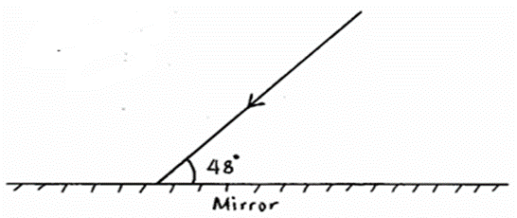

Determine the angle of reflection when the mirror is rotated 10° anticlockwise and the incident ray stays in position. (2marks)

………………………………………………………………………………………………………………………………………………………………………………………………………………